April 4, 2014

Japanese Government Launches New Website on Japanese Territory

1. On April 4, the Ministry of Foreign Affairs of Japan launched a new website on the Japanese Territory in order to strengthen overseas public relations regarding the territory of Japan. (Note 1)

2. The pages in the Ministry’s website on the Northern Territories, Takeshima, and the Senkaku Islands have been incorporated into the above site, and redesigned to make them more easily accessible and understood.

3. This site is available in twelve languages (Note 2), allowing for effective communication with a wide range of people around the world. It is hoped that this will lead to the promotion of a more correct understanding regarding the Japanese territory among the international community.

Note 1: Website on Japanese Territory
(http://www.mofa.go.jp/territory English page)
The site, which has been launched within the website of the Ministry of Foreign Affairs of Japan, provides information related to the Japanese territory and territorial disputes. Using a map of Japan, the site links to the pages on the Northern Territories, Takeshima, and the Senkaku Islands. A special banner has been placed on the top page of the Ministry’s website.

Note 2: The twelve languages used on the site are English, Arabic, Chinese (simplified), Chinese (traditional), French, German, Italian, Korean, Portuguese, Russian, Spanish, and Japanese (Some contents are not available in all twelve languages).

(Attachment)
Special banner for top page

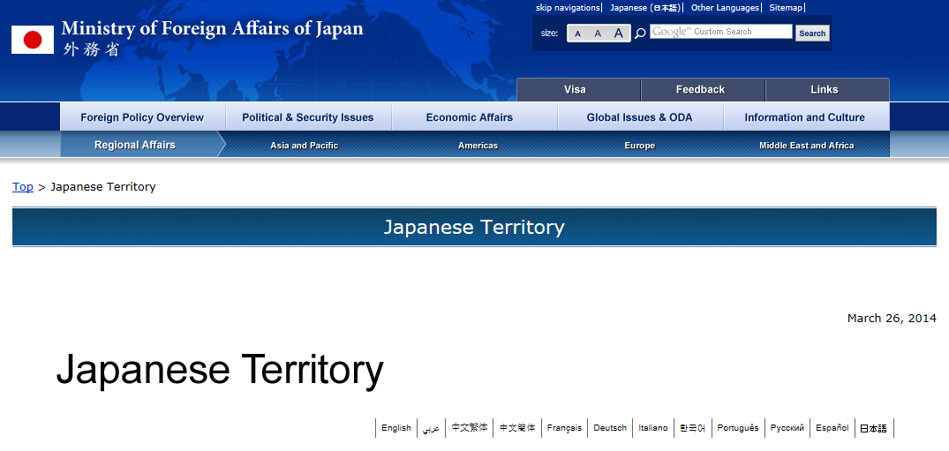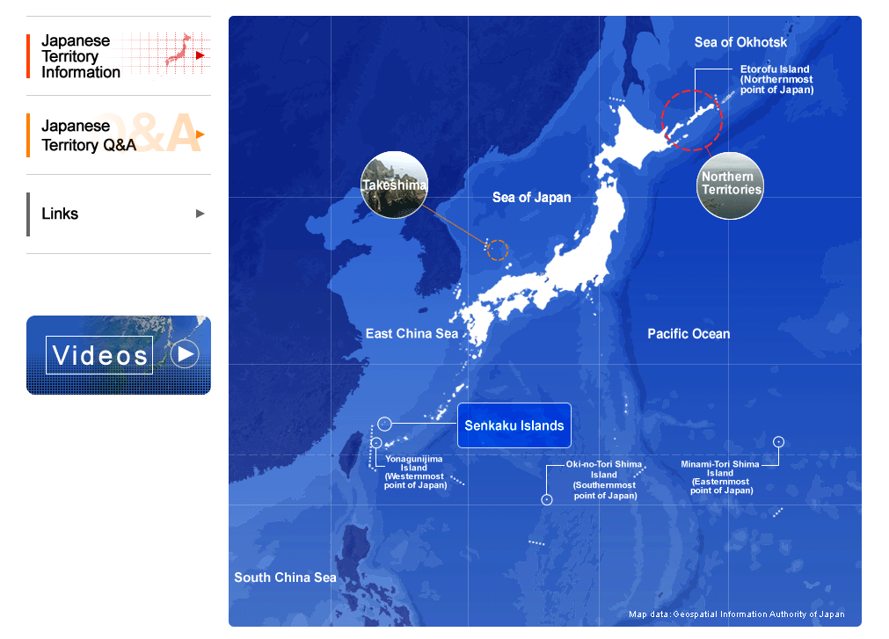
Website on Japanese Territory

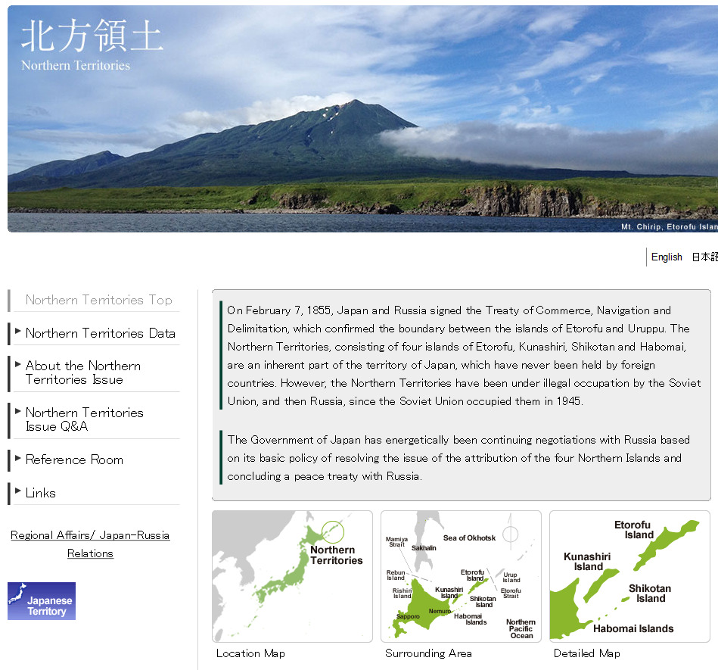

Northern Territories page

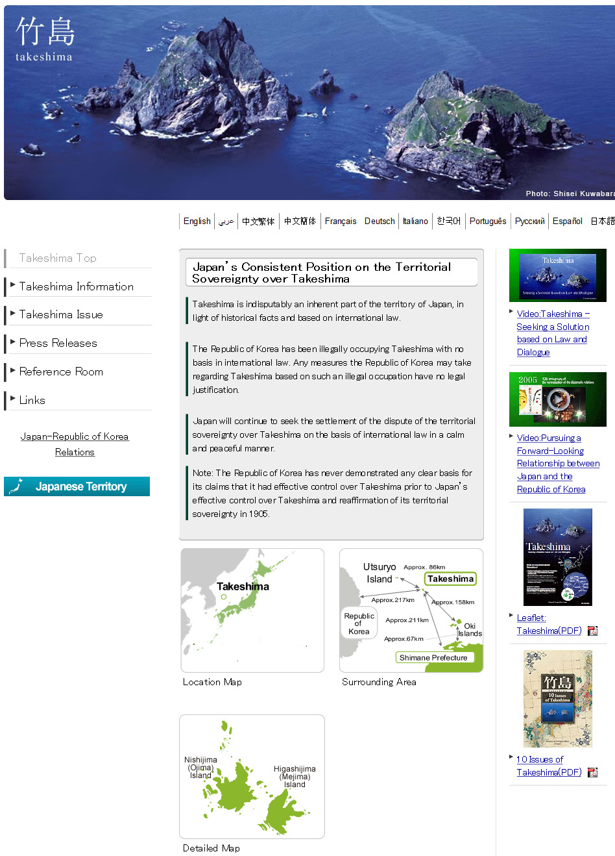

Takeshima page

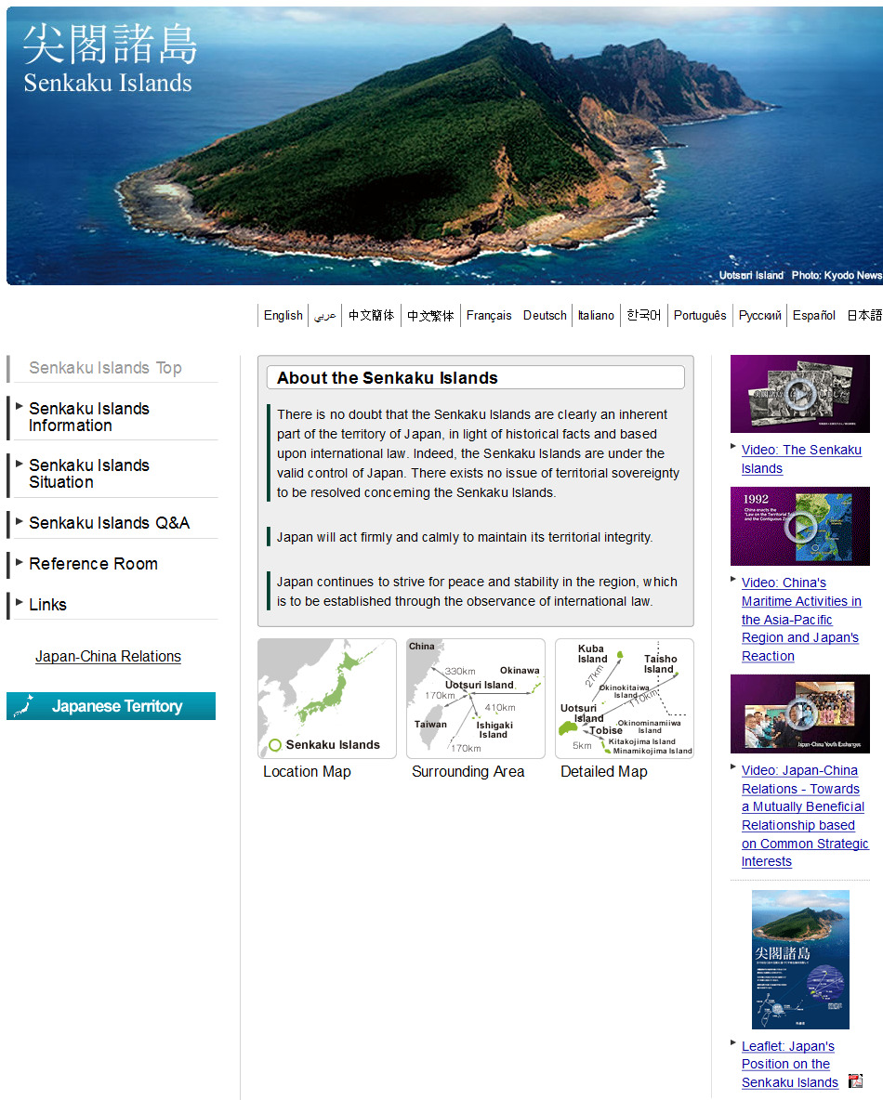

Senkaku Islands page

